EARLY LEARNING COALITION OF SOUTHWEST FLORIDA
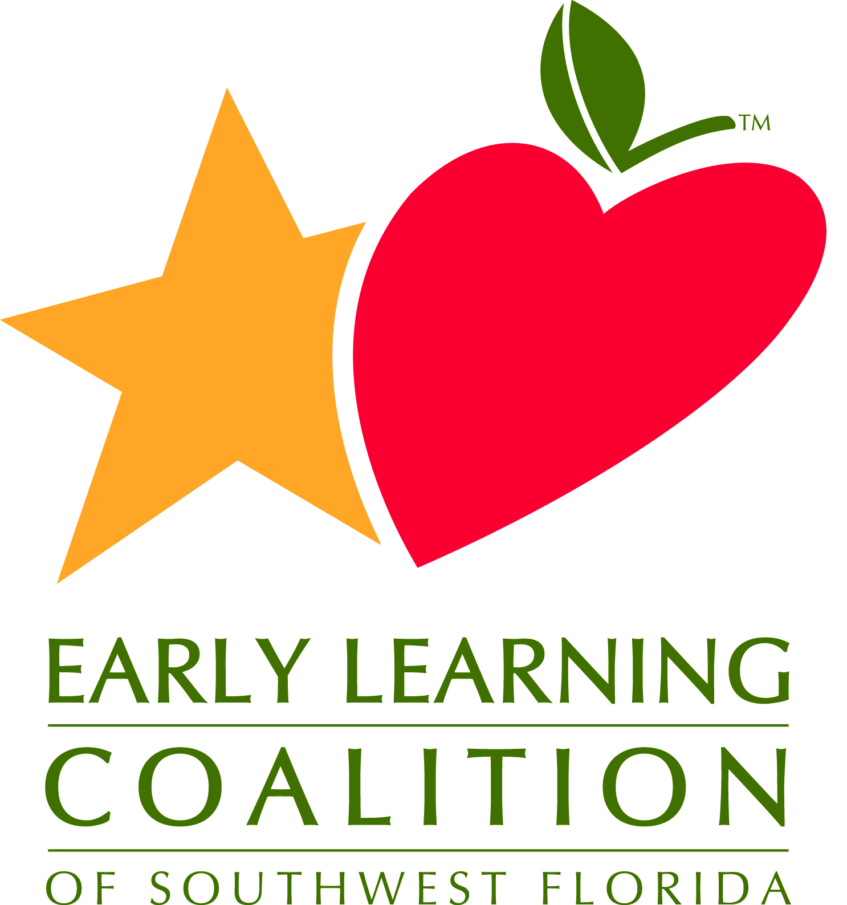
Program Committee
Friday, May 31, 2019
9:00 – 11:00 am

Purpose: The purpose of the Program Committee is to provide professional supports and leadership to advance the quality of early learning programs in Collier, Glades, Hendry and Lee Counties
Committee Members: Damaris Boone (RCMA – Board Member –Committee Chair); Ana Neuhauser (RCMA); Angela Anderson (Child Care of Southwest Florida): Ashley Houk (First Presbyterian Church Naples); Donna Hernandez (Ft. Myers Technical College); Elizabeth Perdomo (Florida Southwestern State College); Gail Mishler (Wellington Ft. Myers); Heather Singleton (Gladiolus Learning and Development Center); Jesyca Vernig (The Learning Tree); JoAnne Fuciu (Lee Memorial Hospitals); Kelly Roy (Florida SouthWestern State College); Kendra Stamp (EduCare); Kim Gerbasio (Lee Public Schools - LAMP); Mandy Willis (Faith Academy) Marie Liebensohn Morales (Lee Memorial Hospital); Michelle King (Child Life Director, Lee Health); Michelle Starr (Collier County Public Schools); Patricia Hansen (Nurse Consultant); Paul Welch (Sonrise Academy); Renate Engels (Guadalupe); Rodrigo Gamboa-Dominguez (Challenged Minds Learning Center; Sherri Shupp (RCMA); Stephanie Rode (St. Andrew Catholic School); Yara Duchesne (RCMA);
Staff Members: Susan Block (CEO); Kristi Biffar (Supervisor of Early Learning Childhood Specialists); Gayla Thompson (CQO); Kim Usa (COO)

Agenda Items | Facilitator/Presenter | Suggested Time Frames
Welcome and Introductions | - Damaris Boone | 9:00 – 9:10
Approval of Meeting Minutes for April 25, 2019 | - Damaris Boone | 9:10 – 9:15
ELC Report | - Susan Block | 9:15 – 9:30
SR Program Assessments | - Kristi Biffar | 9:30 – 9:45
Kindergarten Readiness Rates | - Bronwyn Gogia | 9:45 – 10:00
Schedule change for March | - Gayla Thompson | 10:00 – 10:05
SWFL Stars Report | - Kristi Biffar | 10:05 – 10:15
SR, VPK, Waitlist numbers – Enrollment status | - Director of Family Resources | 10:15 – 10:30
Other Discussion/Events | - All | 10:30 – 10:50
Meeting Calendar, 2019-2029 | - Gayla Thompson | 10:50 – 11:00
Adjournment |  | 11:00
Next Meeting
All meetings will be held at 2675 Winkler Avenue, Fort Myers, FL 33901 unless otherwise announced.
Zoom information
Or phone in 1-669-900-6833

