EARLY LEARNING COALITION OF SOUTHWEST FLORIDA
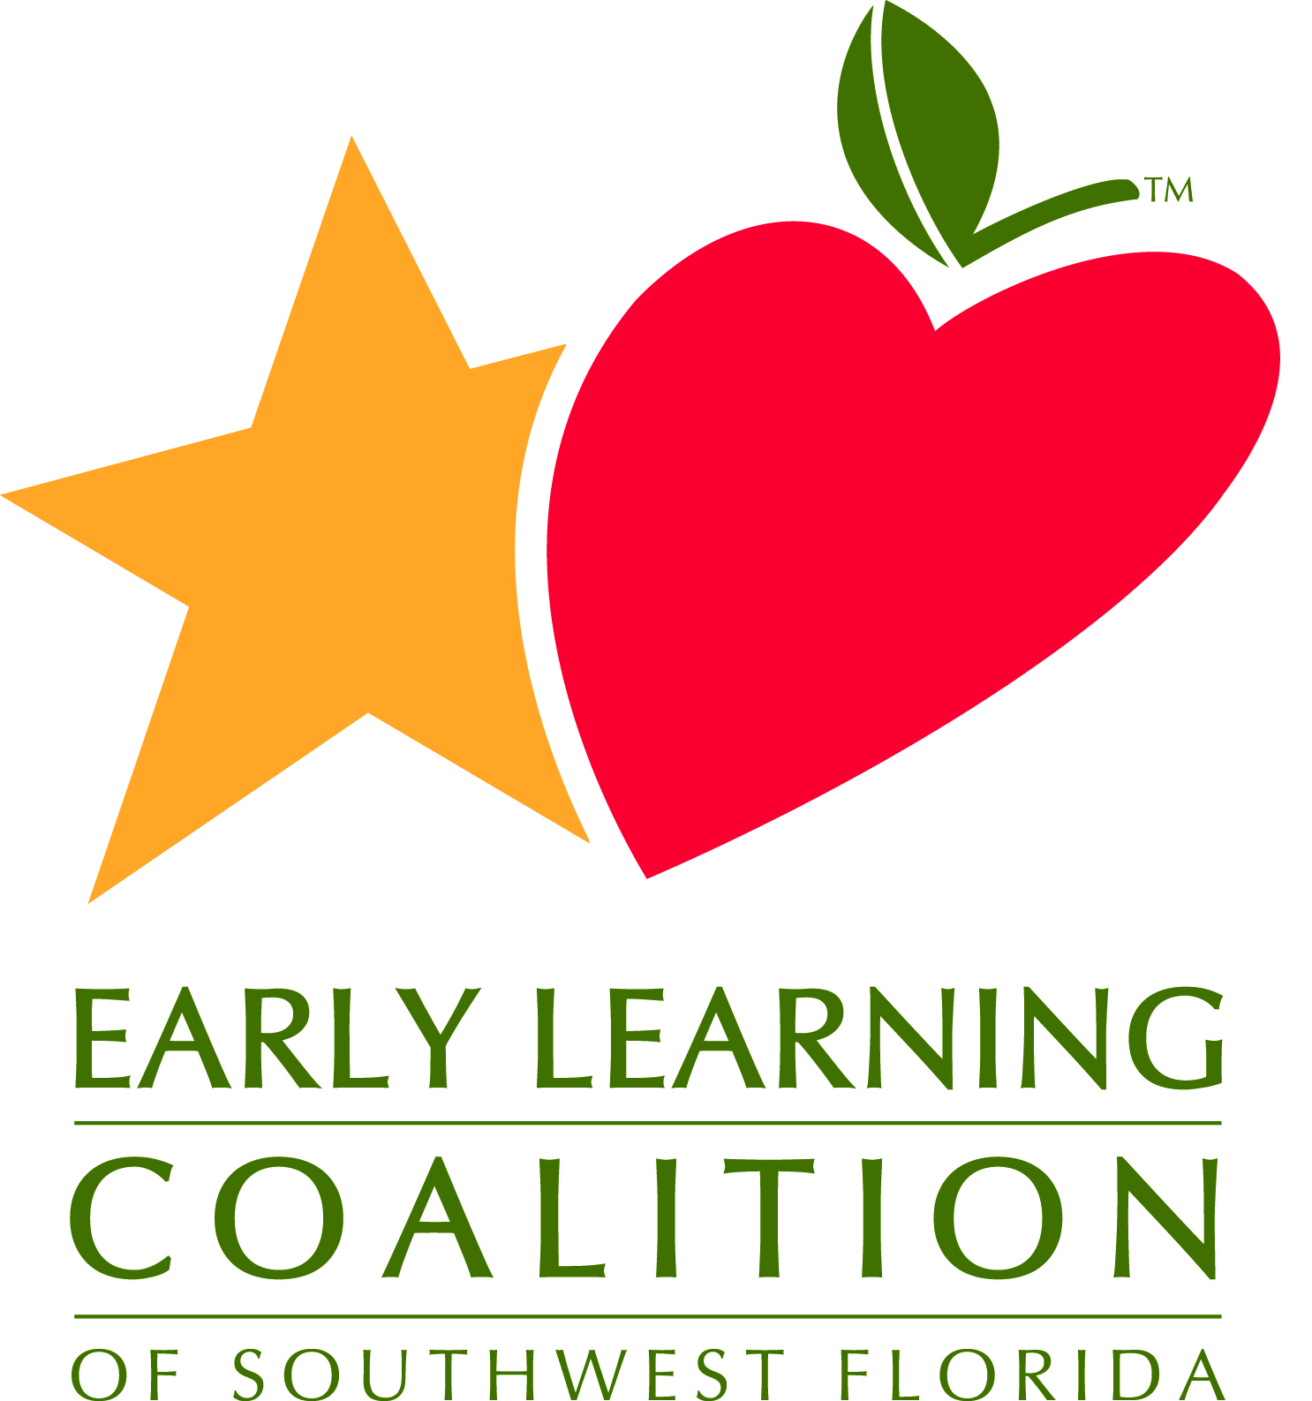
Nominations & By-Laws Committee via Zoom
Meeting Minutes
May 24, 2022
3:00 pm

Purpose: This committee will approve and ensure adherence to the Coalition’s Bylaws and the responsibilities for recruiting members, nominating officers, and development of Board policies as they relate to Board membership and upholding the Coalition’s required membership composition.
Goals:
• Ensure ELCSWFL Bylaws are current, reflect all legal requirements, and reviewed annually for Board approval.
• Confirm that the ELCSWFL Board Policies are reviewed and approved annually by Board of Directors.
• Provide oversight that the ELCSWFL Board membership and composition requirements are met.
• Oversee ELCSW Board plan for the recruitment of potential candidates for Board and Committee membership is reviewed annually.

Committee Members: Dr. Kelly Roy, Chair Professor/Early Childhood Education Coordinator, Florida Southwestern State College; Rebecca McKellar, Creative World Schools, Private for-Profit Child Care; Kim Ross, Ross Dynasty Cares

Presenters: Erin Smelter, Executive Director, & Molly Grant, Deputy Director, Association of Early Learning Coalitions (AELC)

Committee Members, Absent: Mary Grace Romo, Director, Early Childhood Learning Services, Lee County Public Schools
Tanya Williams, Director, Collier County Library Designee-Collier Board of County Commissioners.

Staff Members: Susan Block, Chief Executive Officer

Agenda Items | Discussion | Actions
Welcome & Public Comment | Meeting opened at 3:02 PM | - Quorum was established
Board Development:  - Strategic Planning: May 2022 | - Kelly Roy moved this item to the beginning of the meeting. Molly Grant and Erin Smeltzer led the committee in discussion about each of the two end statements. They led the committee through a discussion of the goals, strategies, and measures for each strategy.  - The statements for the board were completed. Staff contributions will be a part of the full draft to be presented at the June 22, 2022, board meeting for final approval.
Approval of Meeting Minutes for  - April 19, 2022 |  | - Motion to approve the April 19, 2022, minutes by Kim Ross. Second by Rebecca McKellar. Motion approved.
ELC Update | Susan Block reported on challenges at the ELC to fill staff vacancies. In the 2023 year, the ELC is expected to receive a large increase in School Readiness funding. We await the Governor’s signature to approve the budget.
Committee Meeting Calendar: FY 2023 |  | - Motion to approve the schedule for the FY 2023 by Rebecca McKellar. Second by Kim Ross. Motion approved.
Review of Board Vacancies and Recruitment Efforts:  - Current Roster: Status Update and Roster Review  - Governor’s Appointees: Status | - There are three vacancies for Gubernatorial appointees. This remains the highest priority for recruitment.  - Susan Block reviewed the current board roster, noting, Joe Paterno is retiring. A new designee will be announced by incoming director Peg Elmore.
Adjournment: Next meeting – September 8, 2022 | - Meeting ended at 3:58 pm. | - Motion to adjourn by Rebecca McKellar. Second by Kim Ross. Motion approved.

